# Overview

This document contains the necessary information to build the Willow Joystick, a low force magnetic joystick for users with low strength and range of motion

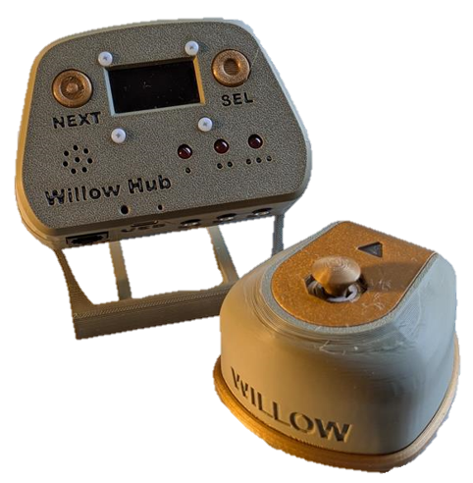

Contents

Overview 1

Maker Checklist 4

Maker To Do List 4

Items to Give to User 4

Tool List 5

Tools / Equipment 5

Supplies 5

Personal Protective Equipment (PPE) 5

Customization Guide 6

Custom Printed Circuit Board (PCB) Guide 7

Ordering the Custom PCB 7

3D Printing Guide 8

3D Printing Summary 8

3D Printing Settings 8

Post-Processing 9

Examples of Quality Prints 10

Maker Component List 14

Assembly Guide 21

Part A: Hub PCB Assembly 22

Part A: Components 22

Part A: Tools 23

Part A: Personal Protective Equipment (PPE) 23

Part A: Hub PCB Assembly Steps 24

Part B: Hub Enclosure Assembly 31

Part B: Components 31

Part B: Tools 32

Part B: Personal Protective Equipment (PPE) 32

Part B: Assembling Hub Enclosure Steps 33

Part C: Joystick Assembly 38

Part C: Required Components 38

Part C: Required Tools and Supplies 39

Part C: Required Personal Protective Equipment (PPE)Safety glasses 40

Part C: Joystick Assembly Steps 40

Part D: Optional Components 50

Part D: Required Components 50

Part D: Required Tools and Supplies 50

Part E: Flashing Firmware to Willow 54

Part E: Required Components 54

Part E: Required Tools and Supplies 54

Troubleshooting 57

Testing 57

Testing the Willow 57

Testing Mouse Mode 57

Testing External Switches 57

Testing Hub Buttons 58

# Maker Checklist

This list provides an overview of the steps required to build and deliver the Willow Joystick.

## Maker To Do List

* Read through the Maker Guide to become familiar with required components, tools, supplies, safety gear, and overall assembly steps.
* Talk to the User about customization options
  + Refer to the Customization Guide section of the Maker Guide
  + Colour of hub, colour of joystick
    - Joystick shell and base can be separate colours for a two-tone effect.
  + What toppers do they want
    - Review the topper selection guide for what toppers are available
  + What mounting supplies do they need
    - Camera mount adaptors, non-slip feet, hub stand, mounting arms, etc.
  + Do they want a wrist ramp
    - Flat ramp, right side flat, left side flat, no sides flat
    - Do they want the standard size, or a customized one.
  + How they would like to receive the “User Guide” (PDF or physical copy)
* Order custom PCB
* Order hardware components
* Gather tools, supplies, and safety equipment.
* Assemble the Willow Hub
* Assemble the Willow Joystick
* Flash firmware to the Willow Hub
* Test the Willow Joystick
* Print “User Guide” (if the User would like a physical copy)

## Items to Give to User

* Willow Joystick
* Joystick Toppers
* Willow Hub
* USB C cable
* RJ11 Cable
* Hub Stand (If asked for)
* Non- Slip Foot (If asked for)
* Camera Mount Adaptor (If asked for)
* “User Guide”
* “Quick Start Guide”

# Tool List

## Tools / Equipment

|  |  |  |  |
| --- | --- | --- | --- |
| Tool ID | Description | Required / Recommended | Notes |
| T01 | Soldering Iron | Required | For soldering electronic components. |
| T02 | Wire Strippers | Recommended | For stripping the insulation off the stemma-Dupont cable if the headers fall off |
| T03 | Phillips Screwdriver | Required | A jeweller’s screwdriver or similar for securing M2.5 machine screws |
| T04 | Flush Cutters | Required | For trimming soldered leads |
| T05 | Crescent wrench / wrench / hex key | Recommended | For installing T-nuts into Hub and Joystick enclosures. |
| T06 | Sandpaper/Files | Recommended | Cleaning up 3d prints; fixing bearing fits |
| T07 | Needle Nose Pliers | Recommended | Installing bearings; routing cables |
| T08 | Computer with Arduino IDE | Required | For flashing firmware to microcontroller |

## Supplies

|  |  |  |  |  |
| --- | --- | --- | --- | --- |
| Supplies ID | Description | Quantity | | Notes |
| S01 | Solder | <6 inches | Soldering | |

## Personal Protective Equipment (PPE)

|  |  |  |
| --- | --- | --- |
| PPE ID | Description | Notes |
| P01 | Safety Glasses | Preventing things from flying into the maker’s eye when trimming wires or other parts. |

# Customization Guide

## Colours

* The joystick and hub can be printed in the user’s desired colour.
* The text on the joystick and hub can be printed in a different colour using a printer with a multi material system, or a colour swap can be done on the hub after the first two layers to increase the contrast on the hub. A second layer swap can also be used to make the hub colours more consistent.

## Toppers

* There are a variety of toppers available, as well as the base file to design your own custom topper. Refer to the included topper selection guide for more information. Make sure to consult with the user on this so that they can pick the best topper for them.
* If the user does not like any of the toppers available, there is a Fusion 360 file available to create a custom topper, as well as a topper intended for use with heat moldable plastic pellets

## Mounting

* There is an optional arm rest available, with the design file included if the user needs a different height, length, etc.
* There is an optional non-slip base available for the Joystick, as well as mounting adaptors for ¼-20 thread and RAM B mount.

# Custom Printed Circuit Board (PCB) Guide

The Willow Joystick Hub uses one custom circuit board. This circuit board is the same one used in the LipSync Hub.

The Custom PCB can be ordered from one of a variety of PCB Manufacturers. Typically, the minimum quantity for a custom PCB is five. Shipping options vary significantly in cost and shipping time. Plan on at least a week from the time of order to the PCBs arrival.

## Ordering the Custom PCB

1. Select a PCB Fabrication Company
   1. [JLPCB](https://jlcpcb.com/)
   2. [PCBWay](https://www.pcbway.com/)
   3. [OSH Park](https://oshpark.com/)
   4. [Seeed Fusion PCB](https://www.seeedstudio.com/fusion_pcb.html)
2. Create an account or use a guest login.
3. Upload the Gerber Files (e.g., LipSync_Hub_PCB_2024-02-09.zip).
4. Select the fabrication options:
   1. PCB Layers: 2 Layers
   2. PCB Quantity: 1 (Some companies have a minimum PCB order more than this, usually 5)
   3. PCB Thickness: 1.5 mm
   4. Surface Finish: HASL
   5. PCB Color: Choose what you like. Note that certain colours may impact build time and cost.
   6. The default settings for the other settings should work.
5. Select shipping option.
   1. Shipping options and costs vary significantly. Select the best option based on your budget and timing.
6. Submit the order.

# 3D Printing Guide

The device was originally printed on a Bambu P1S using Bambu Studio

The default speeds were used on all parts except for the two sled pieces. For these prints all speeds and accelerations were turned to 50% of the default value.

**Testing has shown that a printer with automatic bed leveling is needed to properly print the components in the gimbal.**

## 3D Printing Summary

|  |  |  |  |  |
| --- | --- | --- | --- | --- |
| **Metrics** | **Total** | **Hub** | **Joystick** | **Optional** |
| Total Print Time (hour min) | 8:11 | 1:54 | 2:19 | 3:58 |
| Total Number of Components | 27 | 5 | 10 | 12 |
| Typical Total Mass (g) | 243 | 49 | 56 | 138 |
| Typical Number of Print Setups | 4 | 1 | 2 | 1 |

## 3D Printing Settings

Note that the 3D printing material should be assumed to be PLA unless otherwise noted in the table below.

|  |  |  |  |  |  |  |  |
| --- | --- | --- | --- | --- | --- | --- | --- |
| **Print File Name** | **Qty** | **Total Print Time (hr:min)** | **Mass (g)** | **Infill (%)** | **Support (Y/N)** | **Layer Height/ Nozzle Diameter (mm)** | **Notes** |
| **Hub Files** | | | | | | | |
| Willow_Hub_Bottom.stl | 1 | 1:00 | 27 | 20 | N | 0.2/0.4 |  |
| Willow_Hub_LED_Spacer.stl | 1 | 0:07 | 2 | 20 | N | 0.2/0.4 |  |
| Willow_Hub_Next_Button.stl | 1 | 0:05 | 1 | 20 | N | 0.2/0.4 |  |
| Willow_Hub_Select_Button.stl | 1 | 0:05 | 1 | 20 | N | 0.2/0.4 |  |
| Willow_Hub_Top.stl | 1 | 0:37 | 18 | 20 | N | 0.2/0.4 |  |
| **Joystick Files** | | | | | | | |
| Willow_Joystick_Base.stl | 1 | 0:52 | 22 | 20 | N | 0.2/0.4 |  |
| Willow_Joystick_Shell.stl | 1 | 0:31 | 17 | 20 | N | 0.2/0.4 |  |
| Willow_Joystick_Inner_Gimbal_1.stl | 1 | 0:07 | 2 | 20 | N | 0.2/0.4 |  |
| Willow_Joystick_Inner_Gimbal_2.stl | 1 | 0:07 | 2 | 20 | N | 0.2/0.4 |  |
| Willow_Joystick_Outer_Gimbal.stl | 2 | 0:08 | 3 | 20 | N | 0.2/0.4 |  |
| Willow_Joystick_Sled_1.stl | 1 | 0:11 | 3 | 20 | N | 0.2/0.4 | Print at half speed |
| Willow_Joystick_Sled_2.stl | 1 | 0:11 | 3 | 20 | N | 0.2/0.4 | Print at half speed |
| Willow_Joystick_Gimbal_Shield.stl | 1 | 0:03 | 1 | 20 | N | 0.2/0.4 |  |
| Willow_Joystick_Pin.stl | 1 | 0:01 | 1 | 20 | N | 0.2/0.4 |  |
| **Joystick Topper Files** | | | | | | | |
| Willow_Topper_Concave.stl | 1 | 0:06 | 1 | 20 | N | 0.2/0.4 | Optional |
| Willow_Topper_Convex.stl | 1 | 0:07 | 1 | 20 | N | 0.2/0.4 |  |
| Willow_Topper_Goalpost.stl | 1 | 0:09 | 2 | 20 | N | 0.2/0.4 | Optional |
| Willow_Topper_Stick.stl | 1 | 0:09 | 1 | 20 | N | 0.2/0.4 | Optional |
| Willow_Topper_Mouldable.stl | 1 | 0:07 | 1 | 20 | N | 0.2/0.4 | Optional |
| **Optional Files** | | | | | | | |
| Willow_Joystick_NonSlip_Base.stl | 1 | 0:17 | 13 | 20 | N | 0.2/0.4 | Optional |
| Joystick_Camera_Mount_Adaptor.stl | 1 | 0:12 | 7 | 20 | N | 0.2/0.4 | Optional |
| Joystick_RAM_B_Mount_Adapter.stl | 1 | 0:17 | 9 | 20 | N | 0.2/0.4 | Optional |
| Willow_Joystick_Wrist_Ramp.stl | 1 | 2:00 | 85 | 20 | N | 0.2/0.4 | Optional |
| Willow_Hub_Stand_Front.stl | 1 | 0:20 | 10 | 20 | N | 0.2/0.4 | Optional |
| Willow_Hub_Stand_Leg.stl | 2 | 0:07 | 4 | 20 | N | 0.2/0.4 | Optional |

## Post-Processing

Inspect the 3D printed parts for any printing defects, sharp edges, or burrs. Sharp edges and burrs can be removed with sanding or deburring tools.

Some parts, such as the concave topper or the wrist ramp, may need a slight sanding to smooth the surface and make them comfortable for the user.

## Examples of Quality Prints

Compare your 3D prints to the images here. If there are significant differences, you may need to reprint the part.

|  |  |  |
| --- | --- | --- |
| Hub Enclosure Assembly | | |
| Willow_Hub_Bottom.stl | Willow_Hub_LED_Spacer.stl | Willow_Hub_Next_Button.stl |
| Photo of the willow hub bottom print | Good quality print of Hub LED spacer, printed in grey. | Photo of the willow hub next button print |
| Willow_Hub_Select_Button.stl | Willow_Hub_Top.stl |  |
| Photo of the willow hub select print | Photo of the willow hub top print |  |

|  |  |  |
| --- | --- | --- |
| Joystick Enclosure Assembly | | |
| Willow_Joystick_Base.stl | Willow_Joystick_Gimbal_Shield.stl | Willow_Joystick_Inner_Gimbal_1.stl |
| Photo of the willow joystick base print | Photo of the willow joystick gimbal shield print | Photo of the willow joystick inner gimbal 1 print |
| Willow_Joystick_Inner_Gimbal_2.stl | Willow_Joystick_Outer_Gimbal.stl | Willow_Joystick_Pin.stl |
| Photo of the willow joystick inner gimbal 2 print | Photo of the willow joystick outer gimbal print | Photo of the willow joystick pin print |
| Willow_Joystick_Shell.stl | Willow_Joystick_Sled_1.stl | Willow_Joystick_Sled_2.stl |
| Photo of the willow joystick shell print | Photo of the willow joystick sled 1 print | Photo of the willow joystick sled 2 print |

|  |  |  |
| --- | --- | --- |
| Toppers | | |
| Willow_Topper_Concave.stl | Willow_Topper_Convex.stl | Willow_Topper_Goalpost.stl |
| Photo of the willow joystick concave topper print | Photo of the willow joystick convex topper print | Photo of the willow joystick goalpost topper print |
| Willow_Topper_Mouldable.stl | Willow_Topper_Stick.stl |  |
| Photo of the willow joystick mouldable topper print | Photo of the willow joystick stick topper print |  |

|  |  |  |
| --- | --- | --- |
| Optional Parts | | |
| Willow_Hub_Stand_Front.stl | Willow_Hub_Stand_Leg.stl | Joystick_Camera_Mount_Adapter.stl |
| Photo of the willow hub stand front print | Photo of the willow hub stand leg print | Photo of the willow joystick camera thread mounting adaptor print |
| Joystick_RAM_B_Mount_Adapter.stl | Willow_Joystick_NonSlip_Base.stl | Willow_Joystick_Wrist_Ramp.stl |
| Photo of the willow joystick ram B mounting adaptor print | Photo of the willow joystick non slip base print | A photo of willow wrist ramp print |

# Maker Component List

|  |  |  |  |  |  |  |  |  |  |
| --- | --- | --- | --- | --- | --- | --- | --- | --- | --- |
| **Hub PCB Assembly** | | | | | | | | | |
| **A1** | LipSync 4 Hub PCB | QTY 1 | **A2** | Capacitor, 10uF | QTY 1 | **A3** | Resistor R1, 100 Ω, ¼ W, Through hole | | QTY 1 |
| LipSync Hub circuit board. | | | A yellow capacitor with a white background. | | | A resistor diagram showing the correct resistors A resistor diagram showing the correct resistors | | | |
| **A4** | Resistor R2/R3/R4 68 Ω, ¼ W, Through hole | QTY 3 | **A5** | Tactile Buttons S1/S2 | QTY 2 | **A6** | Piezo Buzzer PS1240 | | QTY 1 |
| A resistor diagram showing the correct resistors A resistor diagram showing the correct resistors | | | A photo of 1 tactile buttons on a white background. | | | A photo of a piezo buzzer on a white background. | | | |
| **A7** | Male Header, 4 position | QTY 1 | **A8** | Sparkfun QWIIC Adapter | QTY 1 | **A9** | Mono Switch Jacks | | QTY 3 |
| 4 pin male header | | | Sparkfun stemma adaptor breakout board | | | A 3.5 mm mono jack | | | |
| **A10** | RJ11 Modular Connector Jack | QTY 1 | **A11** | SeeedStudio Xiao nrF52840 | QTY 1 | **A12** | Male Header, 7 position | QTY 2 | |
| A RJ11 jack | | | A Xiao nrf52840 microcontroller | | | A male 7 pin header | | | |
| **A13** | Headers, Female, 7 Position | QTY 2 | **A14** | LEDs, 5mm though hole | QTY 3 | **A15** | Willow Hub LED Spacer | QTY 1 | |
| A photo of two 7 pin female headers on a white background. | | | A red LED | | | LipSync Hub LED spacer | | | |

|  |  |  |  |  |  |  |  |  |  |  |  |  |  |
| --- | --- | --- | --- | --- | --- | --- | --- | --- | --- | --- | --- | --- | --- |
| **Hub Enclosure Assembly** | | | | | | | | | | | | | |
| **B1** | Populated Willow Hub PCB | | QTY 1 | **B2** | | STEMMA QT Cable – 100 mm | | QTY 1 | **B3** | OLED Display | | QTY 1 | |
| Populated LipSync circuit board | | | | A 100 mm stemma cable | | | | | A LED display breakout board | | | | |
| **B4** | Willow Hub Enclosure Top | | QTY 1 | **B5** | | Willow Next Button Pusher | | QTY 1 | **B6** | Willow Select Button Pusher | | QTY 1 | |
| Photo of the willow hub front print | | | | photo of willow hub next button print | | | | | photo of willow hub slect button print | | | | |
| **B7** | Willow Hub Enclosure Bottom | | QTY 1 | **B8** | | Screw, #4, 3/8” Length | | QTY 5 | **B9** | M2.5 Machine Screw, 8 mm | | QTY 4 | |
| photo of willow hub base print | | | | #4 Sheet metal screw, 3/8" length | | | | | A close-up of a M2.5 bolt | | | | |
| **B10** | M2.5 Nut | QTY 4 | | **B12** | T-Nut | | QTY 1 | | **B13** | | Light Pipe | | QTY 1 |
| A close up of a M2.5 nut | | | | A close up of the T-nut | | | | | A close up of the light pipe | | | | |

|  |  |  |  |  |  |  |  |  |  |  |  |  |  |  |  |  |  |  |  |  |  |
| --- | --- | --- | --- | --- | --- | --- | --- | --- | --- | --- | --- | --- | --- | --- | --- | --- | --- | --- | --- | --- | --- |
| Joystick Assembly | | | | | | | | | | | | | | | | | | | | | |
| C1 | | RJ11 Breakout Board | | | QTY: 1 | **C2** | RJ11 Connector | | | | | QTY: 1 | | **C3** | Cable, STEMMA – DuPont, 150 mm | | | | | | QTY: 1 |
| A close up of two connected RJ11 breakout boards | | | | | | A photo of an RJ11 jack | | | | | | | | A photo of a stemma to dupont cable | | | | | | | |
| C4 | | Inner Gimbal 1 | | | QTY: 1 | **C5** | | Magnet | | | | | QTY: 4 | **C6** | Inner Gimbal 2 | | | | | QTY: 1 | |
| photo of willow joystick inner 1 print | | | | | | A close up photo of the magnet | | | | | | | | photo of willow joystick inner 2 print | | | | | | | |
| C7 | Bearings | | | | QTY: 4 | **C8** | | Gimbal Shield | | | | | QTY: 1 | **C9** | Outer Gimbal | | | | | QTY: 2 | |
| A close-up of a metal bearing | | | | | | photo of willow joystick gimbal shield print | | | | | | | | photo of willow joystick outer gimbal print | | | | | | | |
| C10 | TLV493D STEMMA QT Board | | | | QTY: 1 | **C11** | | Sled 1 | | | | | QTY: 1 | **C12** | M2.5 Machine Screw, 8 mm | | | | | QTY: 4 | |
| A close up of the magnetic sensor | | | | | | photo of willow joystick sled 1 print | | | | | | | | A M2.5 Bolt | | | | | | | |
| C13 | | M2.5 Nut | | QTY: 4 | | **C14** | | Sled 2 | | | QTY: 1 | | | **C15** | | Base | | | QTY: 1 | | |
| A close up of a M2.5 nut | | | | | | photo of willow joystick sled 2 print | | | | | | | | photo of willow joystick base print | | | | | | | |
| C16 | | M3 Nut | QTY: 2 | | | **C17** | | Pin | QTY: 1 | | | | | **C18** | | Shell | QTY: 1 | | | | |
| A photo of two metal M3 hex nuts. | | | | | | photo of willow joystick pin print | | | | | | | | photo of willow joystick shell print | | | | | | | |
| C19 | | Screw, #4, 3/8” Length | | | QTY: 3 | **C20** | | Any Willow Topper | | QTY: 1 | | | |  |  | | |  | | | |
| A photo of a #4 3/8" metal pan head screw on a white background. | | | | | | photo of willow joystick convex topper print | | | | | | | |  | | | | | | | |

|  |  |  |  |  |  |  |  |  |  |  |  |  |
| --- | --- | --- | --- | --- | --- | --- | --- | --- | --- | --- | --- | --- |
| Optional Components Assembly | | | | | | | | | | | | |
| D1 | | Nonslip Base | QTY: 1 | | **D2** | | Nonslip Foot | QTY: 8 | **D3** | Wrist Rest | QTY: 1 | |
| photo of willow joystick non slip base print | | | | | Adhesive non slip foot | | | | photo of willow wrist ramp print | | | |
| D4 | Hub Stand Front | | | QTY: 1 | **D5** | Hub Stand Leg | | QTY: 2 | **D6** | ¼-20 Bolt | | QTY: 1 |
| Willow hub stand front print | | | | | Willow hub stand leg print | | | | 1/4''-20 x 1'' Hex Head Tap Bolt | LH Dottie | | | |

|  |  |  |  |  |  |  |  |  |  |  |  |  |
| --- | --- | --- | --- | --- | --- | --- | --- | --- | --- | --- | --- | --- |
| Flashing Firmware | | | | | | | | | | | | |
| E1 | Willow Joystick | QTY: 1 | **E2** | Willow Hub | | | QTY: 1 | **E3** | RJ11 Cable | | | QTY: 1 |
| Assembled willow joystick | | | Assembled Willow hub | | | | | A picture of the RJ11 cable | | | | |
| E4 | USB-C-USB-A Cable | QTY: 1 |  | |  |  | |  | |  |  | |
| A photo of a black USB-C cable on a white background. | | |  | | | | |  | | | | |

# Assembly Guide

|  |  |
| --- | --- |
| Assembly Section | |
| Part A: Hub PCB Assembly | LipSync circuit board with all components installed. |
| Part B: Hub Enclosure Assembly | CAD model of finished willow hub |
| Part C: Joystick Assembly | Assembled willow joystick |
| Part D: Optional Components | The willow non slip baseThe willow wrist rampThe willow hub stand |
| Part D: Flashing Firmware | Assembled willow joystick and hub |

## Part A: Hub PCB Assembly

### Part A: Components

|  |  |  |  |  |  |  |  |  |  |
| --- | --- | --- | --- | --- | --- | --- | --- | --- | --- |
| **A1** | LipSync 4 Hub PCB | QTY 1 | **A2** | Capacitor, 10uF | QTY 1 | **A3** | Resistor R1, 100 Ω, ¼ W, Through hole | | QTY 1 |
| LipSync Hub circuit board. | | | A yellow capacitor with a white background. | | | A resistor diagram showing the correct resistors A resistor diagram showing the correct resistors | | | |
| **A4** | Resistor R2/R3/R4 68 Ω, ¼ W, Through hole | QTY 3 | **A5** | Tactile Buttons S1/S2 | QTY 2 | **A6** | Piezo Buzzer PS1240 | | QTY 1 |
| A resistor diagram showing the correct resistors A resistor diagram showing the correct resistors | | | A photo of 1 tactile buttons on a white background. | | | A photo of a piezo buzzer on a white background. | | | |
| **A7** | Male Header, 4 position | QTY 1 | **A8** | Sparkfun QWIIC Adapter | QTY 1 | **A9** | Mono Switch Jacks | | QTY 3 |
| 4 pin male header | | | Sparkfun stemma adaptor breakout board | | | A 3.5 mm mono jack | | | |
| **A10** | RJ11 Modular Connector Jack | QTY 1 | **A11** | SeeedStudio Xiao nrF52840 | QTY 1 | **A12** | Male Header, 7 position | QTY 2 | |
| A RJ11 jack | | | A Xiao nrf52840 microcontroller | | | A male 7 pin header | | | |
| **A13** | Headers, Female, 7 Position | QTY 2 | **A14** | LEDs, 5mm though hole | QTY 3 | **A15** | Willow Hub LED Spacer | QTY 1 | |
| A photo of two 7 pin female headers on a white background. | | | A red LED | | | LipSync Hub LED spacer | | | |

### Part A: Tools

* Soldering iron
* Flush cutters
* Phillips Head Screwdriver
* OPTIONAL: Solderless Breadboard (For soldering male headers to microcontroller)

### Part A: Personal Protective Equipment (PPE)

* Safety glasses

### Part A: Hub PCB Assembly Steps

Note that all parts will be inserted onto the side of the PCB labeled “Front”, and all soldering will be done on the side labeled “Back”.

#### Step A-01: Solder in 10 micro Farad capacitor, C1.

Insert the 10 micro-Farad capacitor (A2) into the position labeled C1 on the PCB (A1). Bend the leads of the capacitor to the side to hold it in place. Solder the capacitor onto the PCB. Once soldered, trim the extra from the leads.

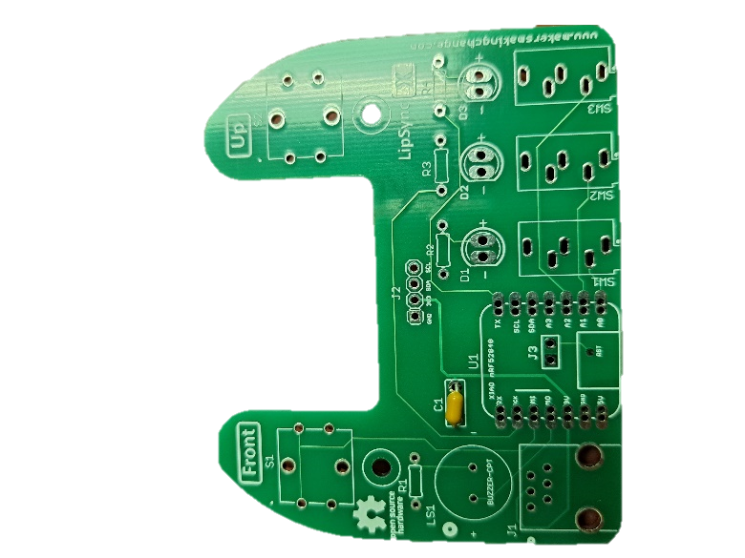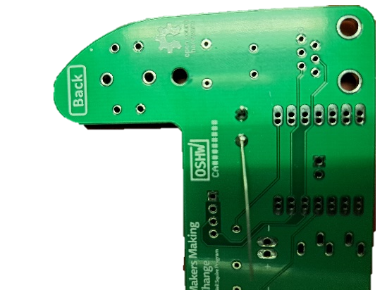

#### Step A-02: Solder in 100 Ohm resistor, R1.

Insert the 100 Ohm resistor (A3) into the position labeled R1 on the PCB. Bend the leads of the resistor to the side to hold it in place. Solder the resistor onto the PCB. Once soldered, trim the extra from the leads.

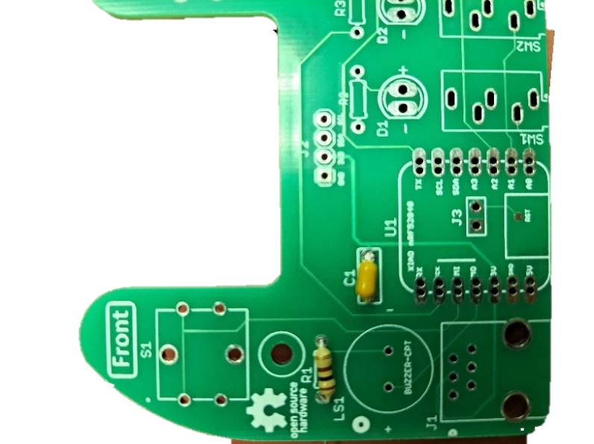

#### Step A-03: Solder in 68 Ohm resistors, R2, R3, and R4.

Insert the 68 Ohm resistors (A4) into the positions labeled R2, R3, and R4 on the PCB. Bend the leads of the resistors to the side to hold them in place. Solder the resistors onto the PCB. Once soldered, trim the extra from the leads.

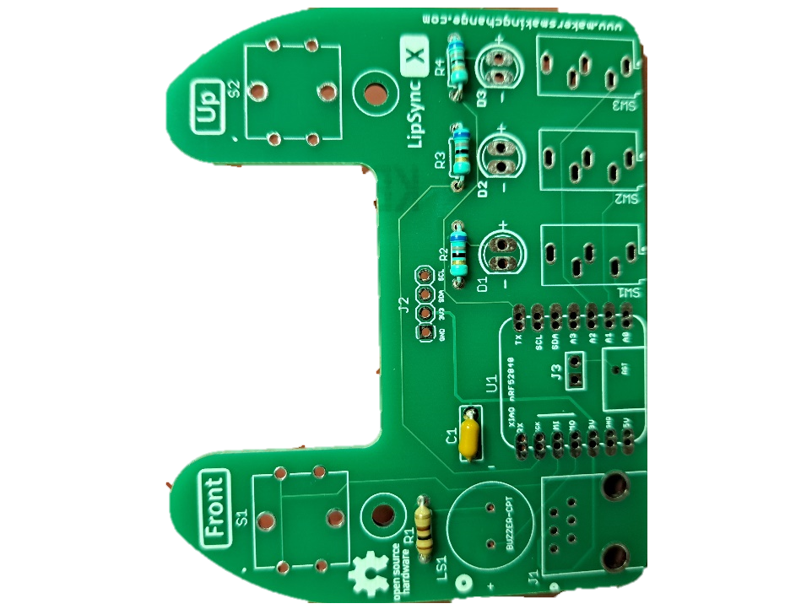

#### Step A-04: Insert, solder, and trim the 4-pin Male header.

Insert the longer pins of the 4-pin male header (A7) into the position labeled J2. Solder it into place and trim the excess from the bottom.

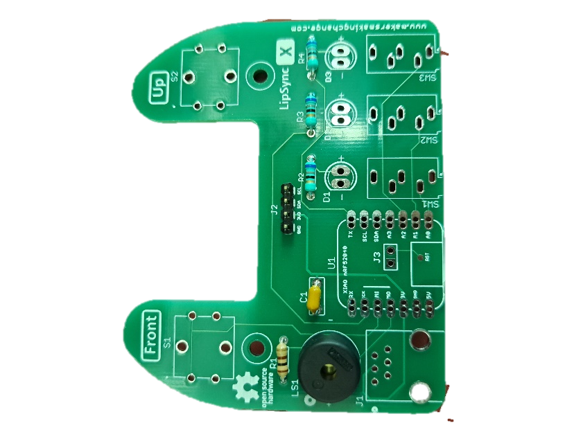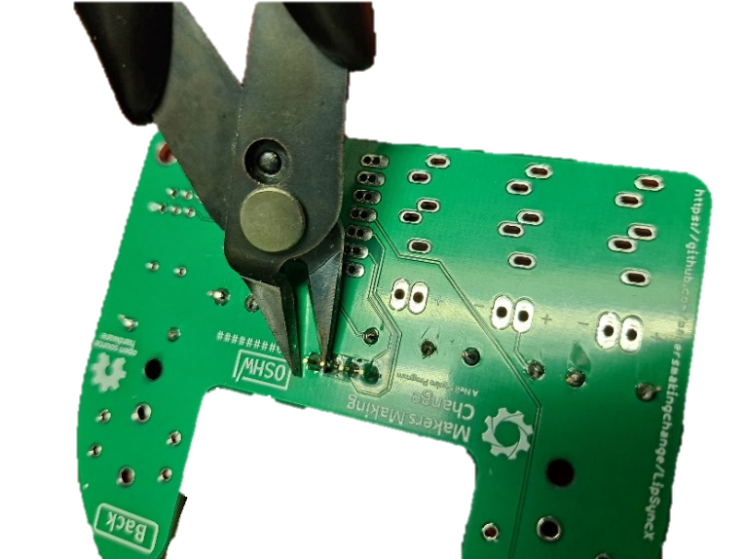

#### Step A-05: Insert, solder, and trim buzzer.

Insert the buzzer (A6) into the position labeled LS1. If using a buzzer with polarity, make sure the positive lead is in the hole marked with a “+” on the PCB. Note that the Piezo Buzzer PS1240 does not have polarity. Bend the leads to the side to hold the buzzer in place. Solder in place and trim excess from the leads.

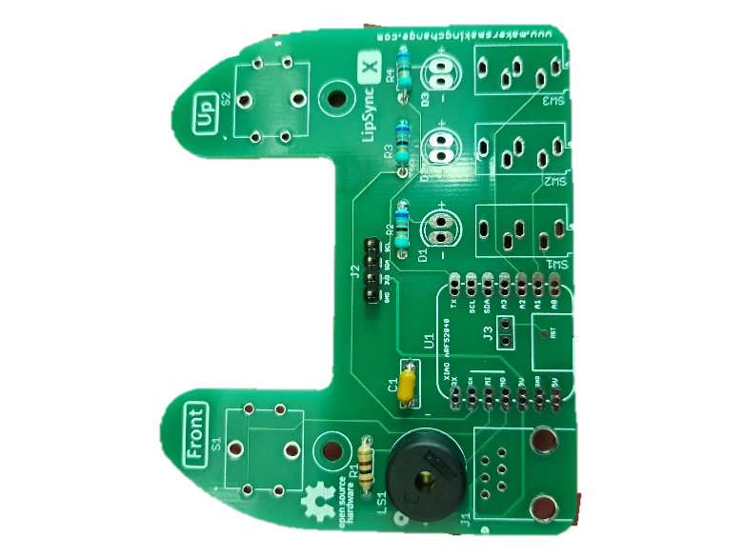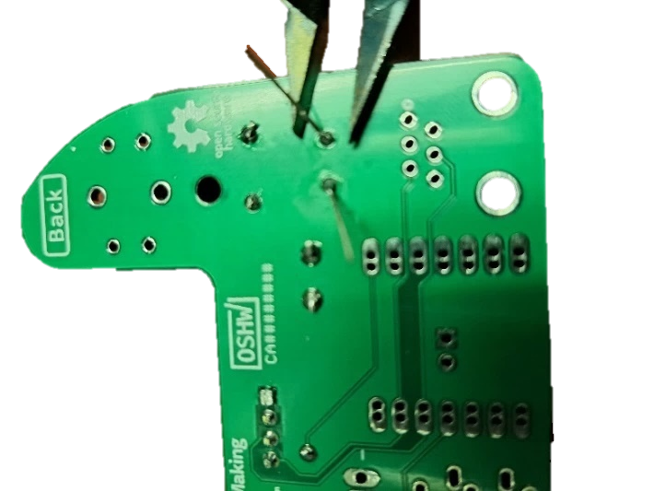

#### Step A-06: Insert, solder, and trim switches.

Insert the two tactile switches (A5) into the positions labeled S1 and S2. Once soldered in place, trim any excess from leads of the switches.

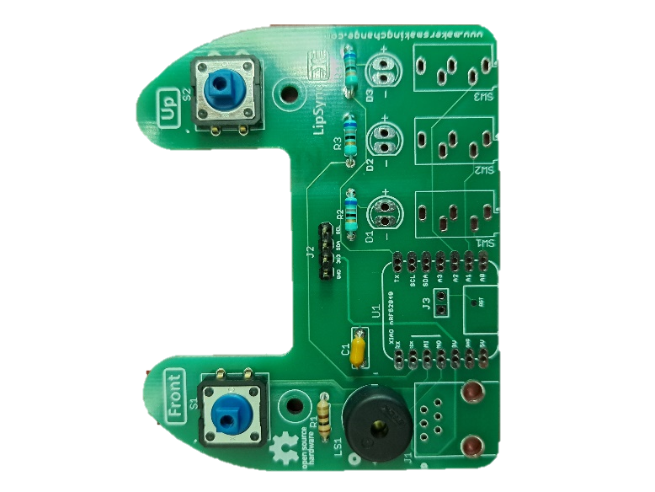

#### Step A-07: Insert and solder SparkFun QWIIC Adapter.

Place the SparkFun QWIIC Adapter (A8) on the 4-pin male header (A7) that was attached to J2 in step A-04. Ensure the pin labels on the adapter matches the pin labels on the Hub PCB. Solder the four pins on the adapter.

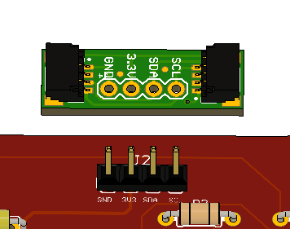

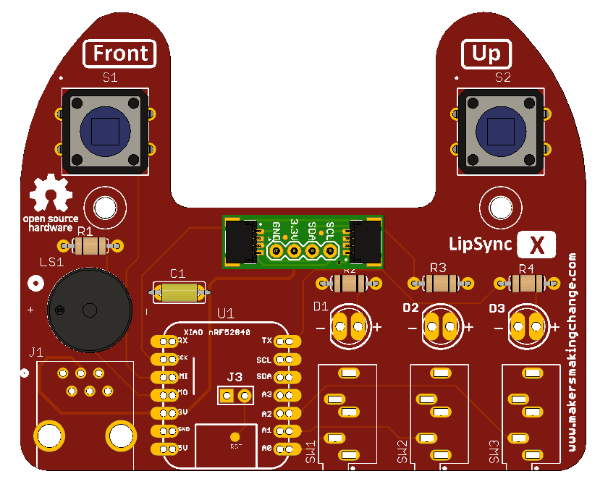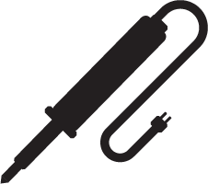

#### Step A-08: Insert and solder switch jacks.

Insert the switch jacks (A9) into the positions labeled SW1, SW2, and SW3. Solder one pin on each switch jack, then check the alignment. If the alignment needs to be changed, reheat the solder joint until the solder melts, then reposition the jack. Once the jacks are positioned properly, solder the remaining pins.

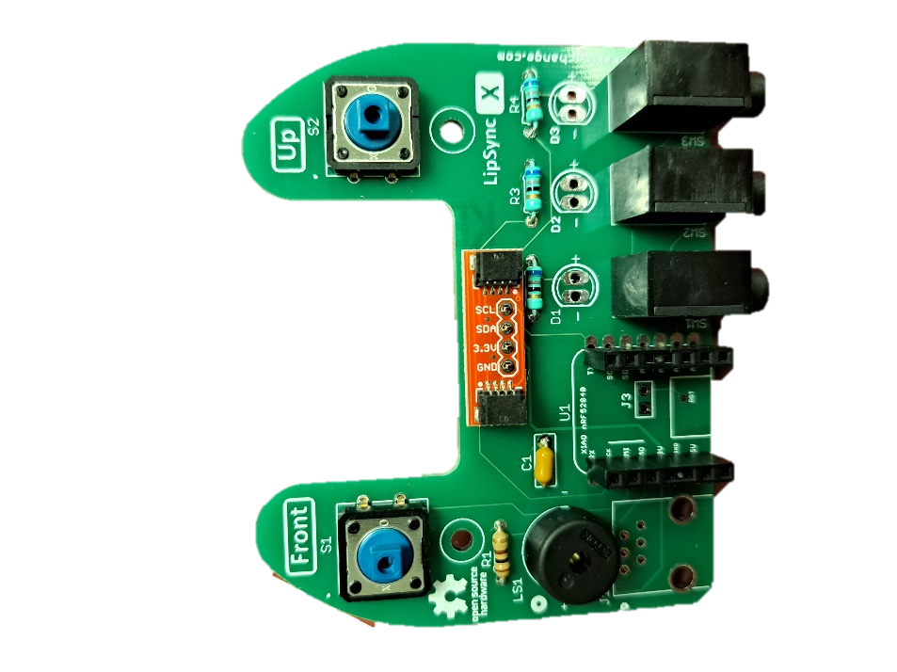

#### Step A-09: Solder male headers onto microcontroller.

Insert the short side of the male headers (A12) into the SeeedStudio Xiao nrf52840 microcontroller (A11) from the bottom of the board. To align the male headers and keep them straight when soldering, take the 7-position female headers (A13), and insert the male headers into the female headers across the microcontroller (as shown in the picture on the left).

Alternatively, a solderless breadboard can be used, plug the unsoldered microcontroller and headers into the protoboard and the protoboard will hold the headers in the proper alignment.

Solder the male headers onto the microcontroller, making sure not to connect adjacent pads together with solder. Once soldered, remove the 7-pin female headers from the male headers.

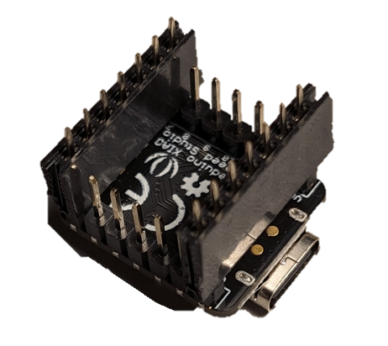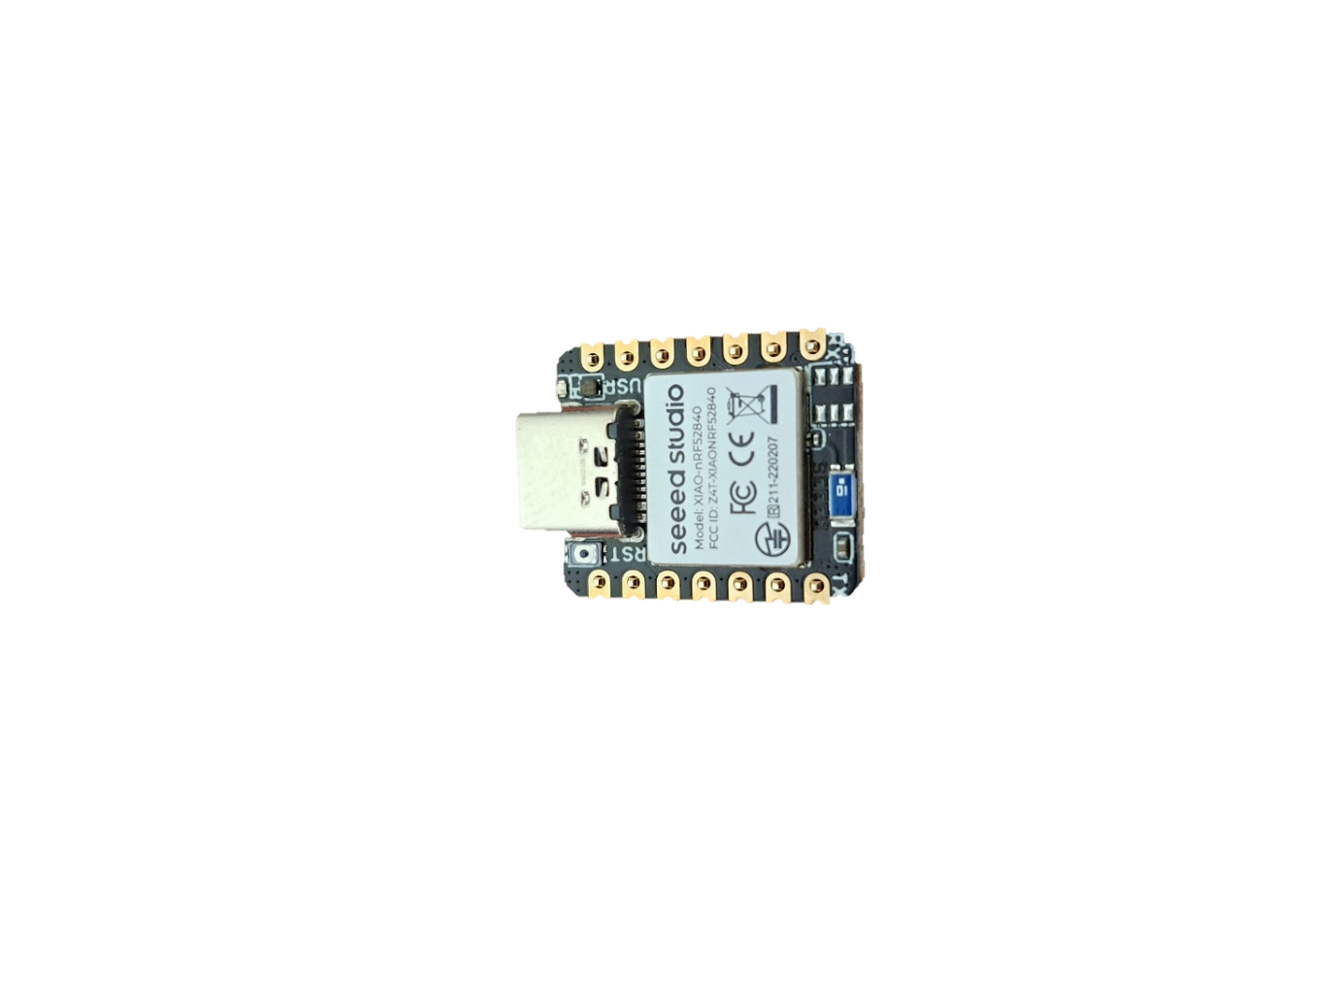

#### Step A-10: Solder female microcontroller header into PCB.

Insert microcontroller with male headers into the female headers (A13). Insert the female headers into PCB. Solder 1 pin on each header. Check alignment and adjust if necessary. If you need to adjust the alignment, heat the single soldered pin until the solder melts again and adjust the position of the row of headers. Once aligned, solder remaining headers.

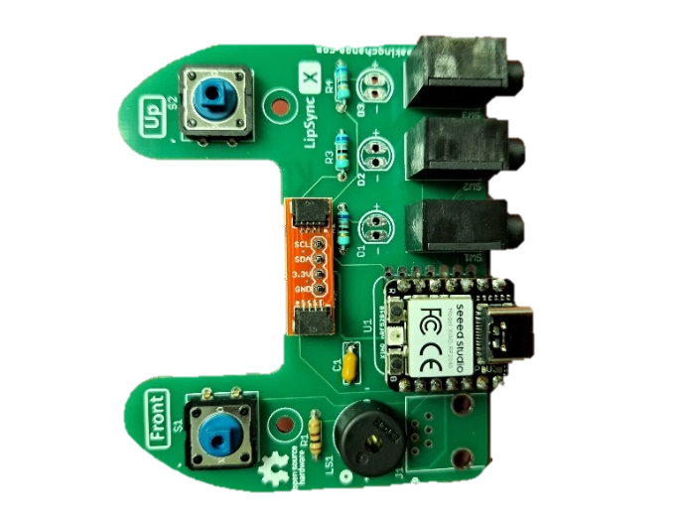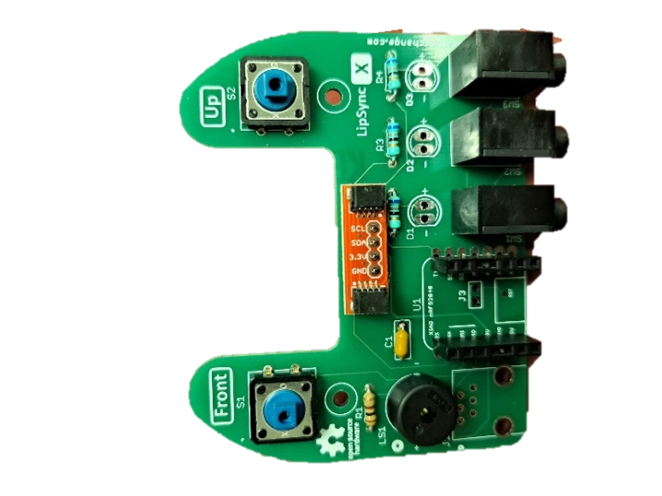

#### Step A-11: Insert and solder the RJ11 jack.

Insert the RJ11 jack (A10) into the position labeled J1 on the PCB. Solder the six pins into place.

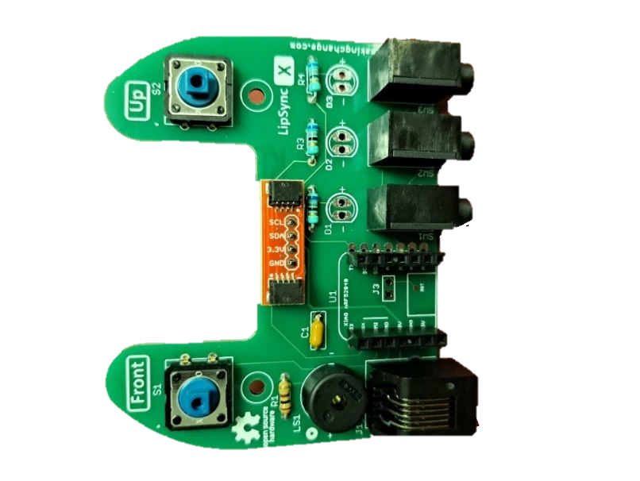

#### Step A-12: Insert, solder, and trim LEDS.

Insert the three LEDs (A14) into the 3D printed LED Spacer(A15). Ensure the shorter lead of the LED (the negative lead) is on the same side as the flat edge of the LED Spacer. The LED will also have a flat edge matching the flat edge on the spacer.

With the LEDs inserted into the spacer, insert the LEDs into the matching holes in the PCB. The flat side of the LED spacer should be on the left with the rounded side on the right, when looking at the PCB from the front. Solder the LEDs in place and trim the excess from the leads.

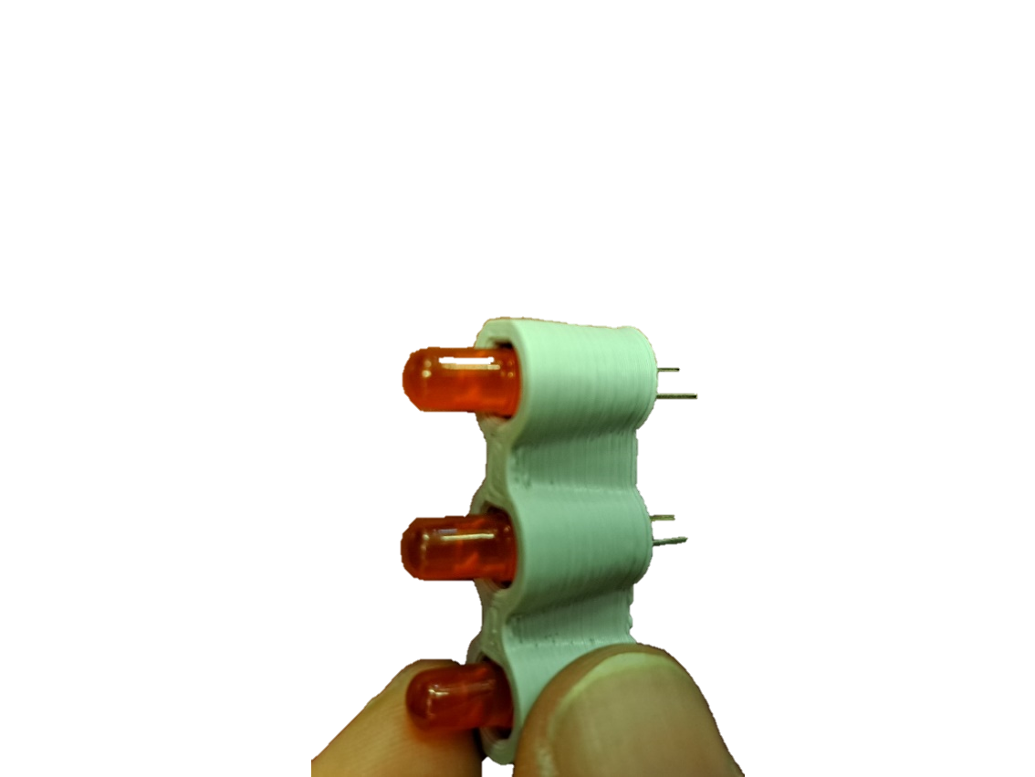 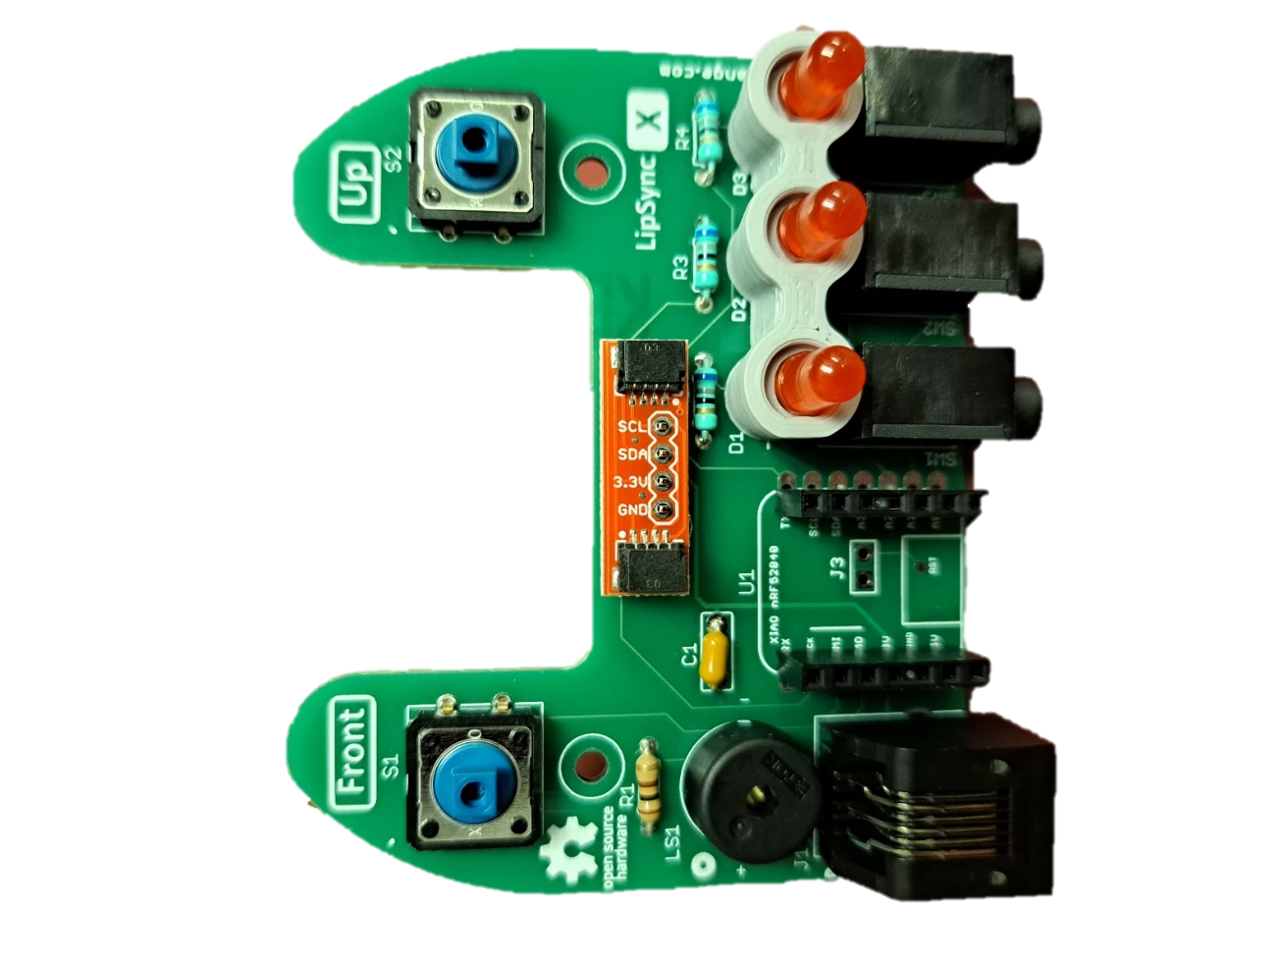

#### Part A Complete

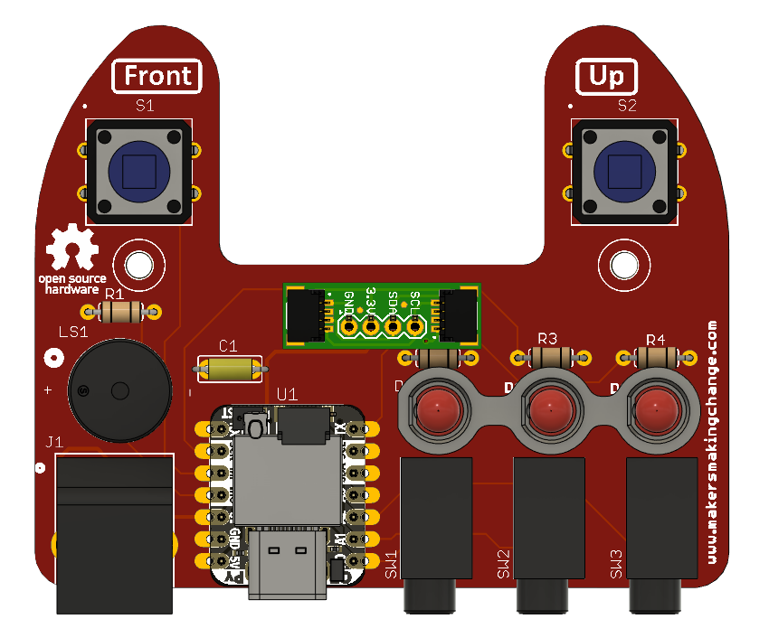

## Part B: Hub Enclosure Assembly

### Part B: Components

|  |  |  |  |  |  |  |  |  |
| --- | --- | --- | --- | --- | --- | --- | --- | --- |
| **B1** | Populated Willow Hub PCB | QTY 1 | **B2** | STEMMA QT Cable – 100 mm | QTY 1 | **B3** | OLED Display | QTY 1 |
| Populated LipSync circuit board | | | A 100 mm stemma cable | | | A LED display breakout board | | |
| **B4** | Willow Hub Enclosure Top | QTY 1 | **B5** | Willow Next Button Pusher | QTY 1 | **B6** | Willow Select Button Pusher | QTY 1 |
|  | | |  | | |  | | |
| **B7** | Willow Hub Enclosure Bottom | QTY 1 | **B8** | Screw, #4, 3/8” Length | QTY 5 | **B9** | M2.5 Machine Screw, 8 mm | QTY 4 |
|  | | | #4 Sheet metal screw, 3/8" length | | | A close-up of a M2.5 bolt | | |
| **B10** | M2.5 Nut | QTY 4 | **B12** | T-Nut | QTY 1 | **B13** | Light Pipe | QTY 1 |
| A close up of a M2.5 nut | | | A close up of the T-nut | | | A close up of the light pipe | | |

### Part B: Tools

* Phillips Head Screwdriver

### Part B: Personal Protective Equipment (PPE)

* Safety glasses

### Part B: Assembling Hub Enclosure Steps

#### Step B-01: Connect Display to Willow Hub Enclosure Top

Peel off the protective film on the Display (B3) and connect it to the Hub Enclosure Top (B4) using four nylon M2.5 machine screws (B9) and four nylon M2.5 hex nuts (B10). Do not overtighten.

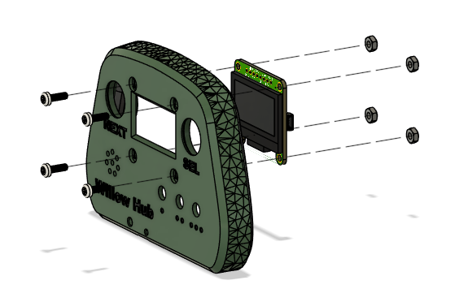

#### Step B-02: Insert the Light Pipe

From the front side, insert the **light pipe** (B13) into the Hub Enclosure Top.

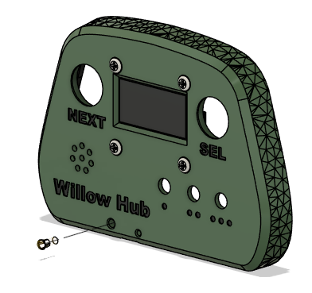

#### Step B-03: Connect STEMMA / QWIIC Cable to Display

Flip the Hub Top over so the Display is facing down. Connect the 100 mm STEMMA/QWIIC cable (B2) to the port on the right-hand side of the Display as shown. Ensure the holes for the pins in the cable line up with the pins in the port on the PCB. Do not connect the second end of the STEMMA/QWIIC cable to the second port on the screen.

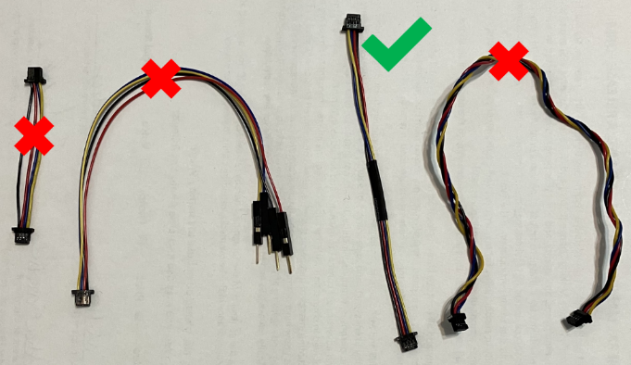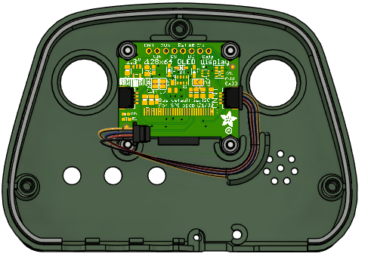

#### Step B-04: Insert the Tee Nut into the Hub Bottom

Insert the tee nut (B12) into the slots inside the Hub Bottom. A ¼” machine screw or hex bolt can be used to tighten the Tee Nut into place. The nut should sit flush with the enclosure.

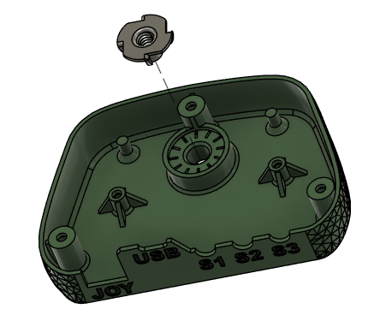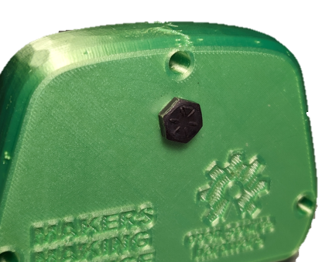

#### Step B-05: Secure Willow Hub PCB into Hub Bottom

Use two #4 sheet metal screws (B8) to secure the PCB (A1) into the Hub Bottom.

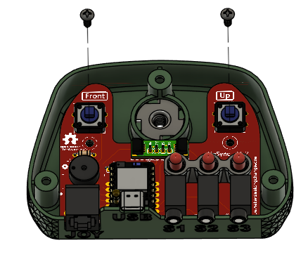

#### Step B-06: Connect the STEMMA / QWIIC Cable to the QWIIC Adapter on the PCB

Connect the 100 mm STEMMA/QWIIC cable from the display to the QWIIC adapter on the PCB. Again, ensure the holes for the pins in the cable line up with the pins in the port on the PCB.

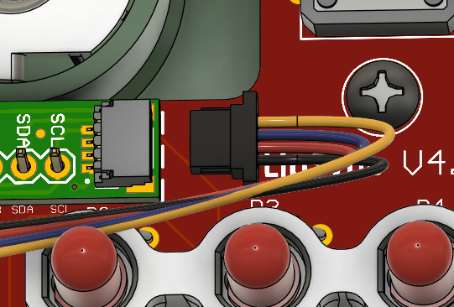 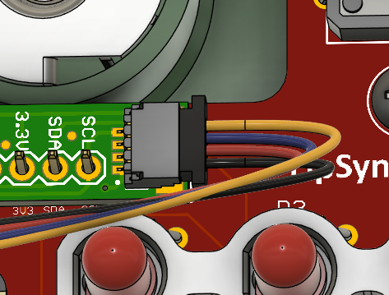

#### Step B-07: Place the Button Pushers on top of the Buttons

Position the Select Button (B6) and the Next Button (B5) on top of the Buttons on the PCB. The Next Button goes on the left button and has a target shape on the front. The Select Button goes on the right button and has a ring printed on the front.

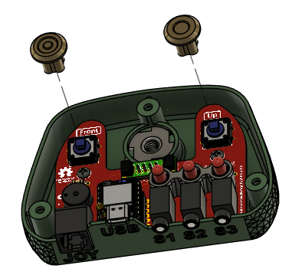

#### Step B-08: Position the Hub Top on to the Hub Bottom

Position the Hub Top onto the Hub Bottom, making sure to align the Button Pushers and their LEDs with the corresponding hole.

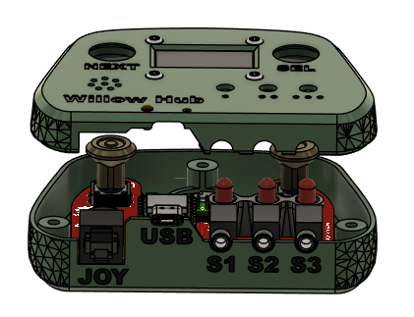

#### Step B-09: Secure the Hub Top and Hub Bottom

Carefully turn the Hub over. Use a #4 sheet metal screw(B8) in each of the three holes to secure the two parts together.

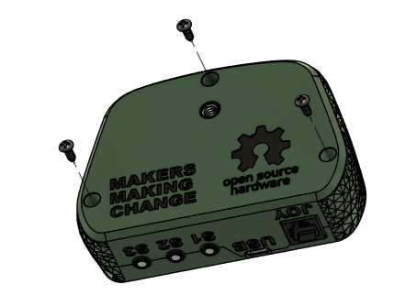

#### Part B Complete

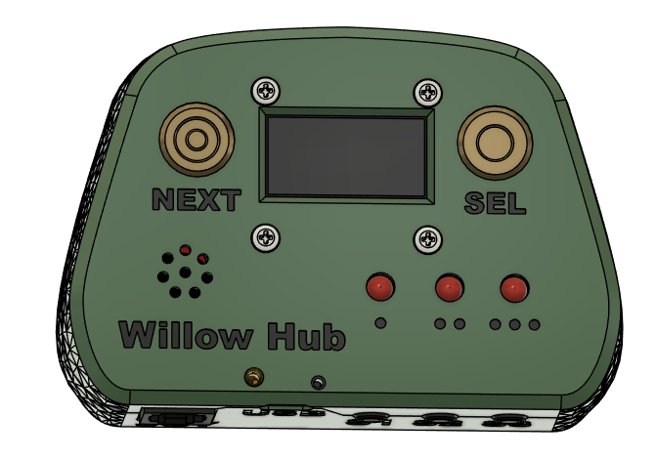

## Part C: Joystick Assembly

### Part C: Required Components

|  |  |  |  |  |  |  |  |  |  |  |  |  |  |  |  |
| --- | --- | --- | --- | --- | --- | --- | --- | --- | --- | --- | --- | --- | --- | --- | --- |
| Joystick Assembly | | | | | | | | | | | | | | | |
| C1 | RJ11 Breakout Board | | QTY: 1 | **C2** | RJ11 Connector | | | QTY: 1 | | **C3** | Cable, STEMMA – DuPont, 150 mm | | | | QTY: 1 |
| A close up of two connected RJ11 breakout boards | | | | A photo of an RJ11 jack | | | | | | A photo of a stemma to dupont cable | | | | | |
| C4 | Inner Gimbal 1 | | QTY: 1 | **C5** | | Magnet | | | QTY: 4 | **C6** | Inner Gimbal 2 | | | QTY: 1 | |
| Willow gimbal inner 1 print | | | | A close up photo of the magnet | | | | | | Willow gimbal inner 2 print | | | | | |
| C7 | Bearings | | QTY: 4 | **C8** | | Gimbal Shield | | | QTY: 1 | **C9** | Outer Gimbal | | | QTY: 2 | |
| A close-up of a metal bearing | | | | willow gimbal shield print | | | | | | willow joystick outer gimbal print | | | | | |
| C10 | TLV493D STEMMA QT Board | | QTY: 1 | **C11** | | Sled 1 | | | QTY: 1 | **C12** | M2.5 Machine Screw, 8 mm | | | QTY: 4 | |
| A close up of the magnetic sensor | | | | willow joystick sled 1 print | | | | | | A M2.5 Bolt | | | | | |
| C13 | M2.5 Nut | QTY: 4 | | **C14** | | Sled 2 | QTY: 1 | | | **C15** | | Base | QTY: 1 | | |
| A close up of a M2.5 nut | | | | willow joystick sled 2 print | | | | | | willow joystick base print | | | | | |
| C16 | M3 Nut | QTY: 2 | | **C17** | | Pin | QTY: 1 | | | **C18** | | Shell | QTY: 1 | | |
| A photo of two metal M3 hex nuts. | | | | Willow joystick pin print | | | | | | willow joystick shell print | | | | | |
| C19 | Screw, #4, 3/8” Length | | QTY: 3 | **C20** | | Any Willow Topper | QTY: 1 | | |  |  | |  | | |
| A photo of a #4 3/8" metal pan head screw on a white background. | | | | Willow joystick convex topper print | | | | | |  | | | | | |

### Part C: Required Tools and Supplies

* Soldering Iron
* Phillps head screwdriver
* Optional: Sandpaper
* Optional: Wire Strippers
* Optional: Needle Nose Pliers

### Part C: Required Personal Protective Equipment (PPE)Safety glasses

### Part C: Joystick Assembly Steps

#### Step C-01: Snap the breakout boards

Separate the two RJ11 breakout boards (C1) by snapping them apart by hand. Snap off the thin portion with the two mounting holes.

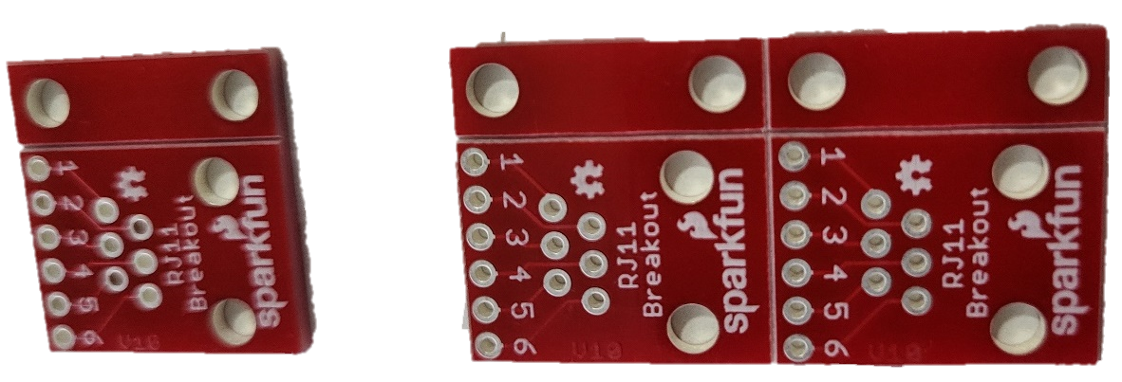 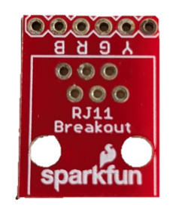

#### Step C-02: Solder the RJ11 jack to the RJ11 Breakout Board

Press the RJ11 Jack (C2) into the breakout board so the pins stick out of the numbered side. Solder the six RJ11 pins poking through the board, **NOT THE NUMBERED HOLES.**

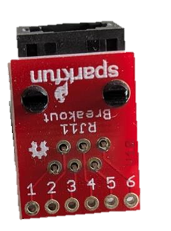

#### Step C-03: Solder the STEMMA QT Cable to the RJ11 Breakout Board

Insert the DuPont headers on the Stemma-Dupont connector (C3) into the through holes on the RJ11 Breakout Board from the same side as the RJ11 Connector, following the order in the table. Solder in place, and trim the DuPont ends sticking out the back side.

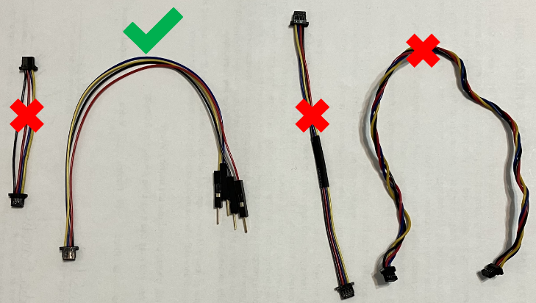

|  |  |
| --- | --- |
| **RJ 11 Breakout** | **STEMMA QT Cable** |
| 2 (B) | Black (Gnd) |
| 3 (R) | Red (Vcc) |
| 4 (G) | Blue (SDA) |
| 5 (Y) | Yellow (SCL) |

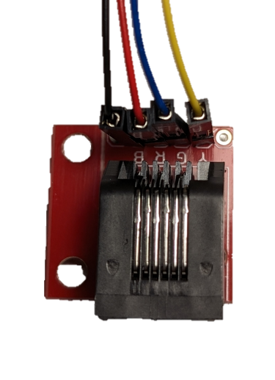

#### Step C-04: Insert the Magnet

Press the magnets (C5) into one of the inner gimbal prints (C4), it is not important which one. It is important that they are both in the same orientation, attracting each other instead of repelling.

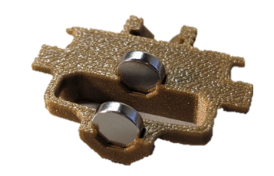

#### Step C-05: Attach second half of inner gimbal

Press the second half of the inner gimbal (C6) onto the first and squeeze it tight.

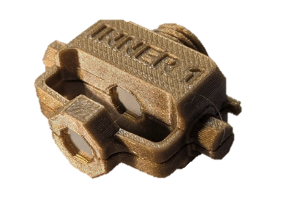

#### Step C-06: Attach inner gimbal bearings

Push bearings (C7) onto the posts on the inner gimbal assembly.

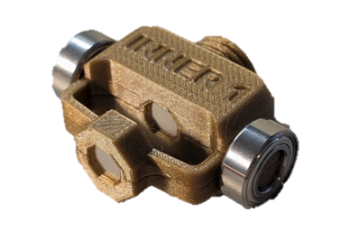

#### Step C-07: Attach the Gimbal Shield

Screw the gimbal shield (C8) onto the threads on the inner gimbal.

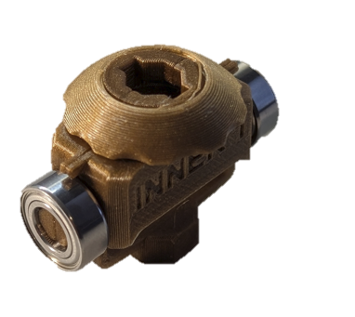

#### Step C-08: Add Outer Gimbal

Take both halves of the outer gimbal (C9) and press them around the inner gimbal. Add the bearings (C7) on the bearing posts to secure them in place.

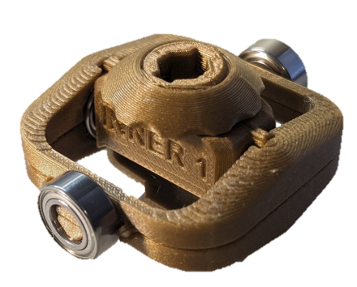

#### Step C-09: Plug Stemma Cable into Magnetic Sensor

Take the stemma cable that is soldered to the RJ11 jack and plug it into the left side of the magnetic sensor board (C10) when looking at it with the text at the top, right side up. Pass the magnetic sensor through the loop at the bottom of the gimbal assembly.

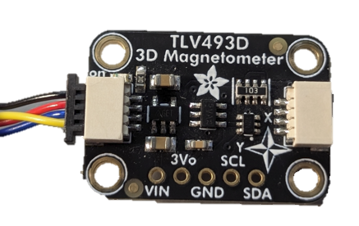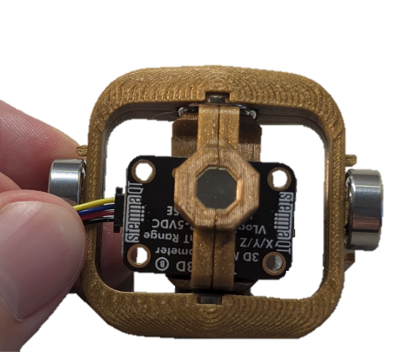

#### Step C-10: Press Gimbal into Sled

Press the gimbal into the sled 1 piece (C11), marked by a single dot by the bottom magnet piece. The magnet in the gimbal should be facing the magnet slot in the bottom of sled 1.

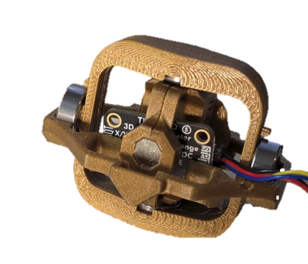 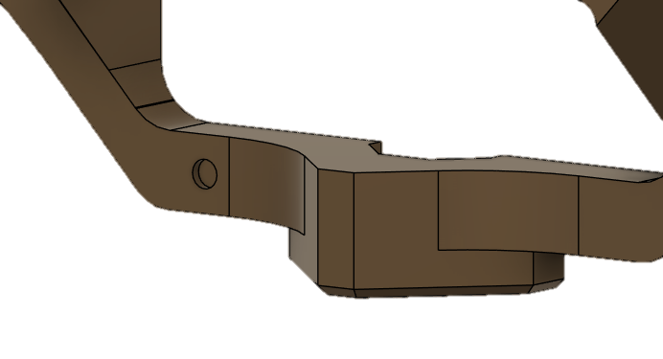

#### Step C-11: Bolt the magnetic sensor into place

Take 2 of the M2.5 bolts (C12) and pass them through the magnetic sensor and sled from the top. Take two of the M2.5 nuts (C13) and secure the bolts in place. Passing the bolts through from the bottom also works, and some makers have found it easier to assemble this way.

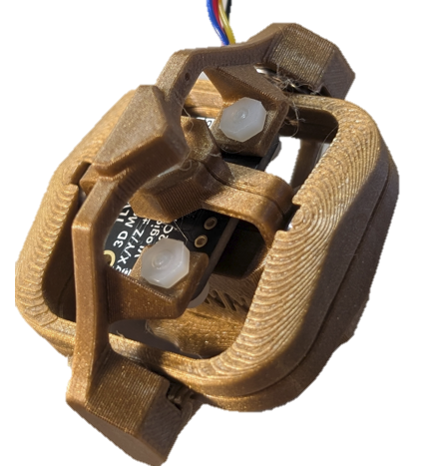 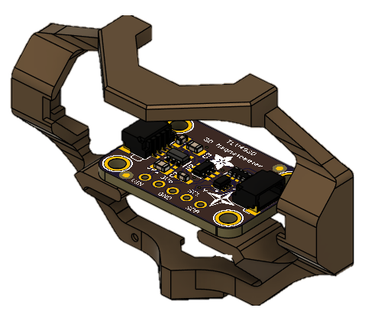

#### Step C-12: Insert the Sled Magnet

Press a magnet into the slot on the base of the sled 2 prints(C14), the one that the magnetic sensor is not bolted to. Make sure it matches the orientation of the other magnets, so that the gimbal is attracted to the base instead of repelled.

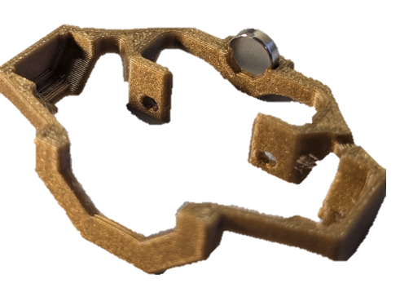

#### Step C-13: Attach Second Half of Gimbal

Press the other half of the gimbal into place so that the magnet is fully captured. Use two of the M2.5 bolts (C12) and nuts (C13) through the magnetic sensor to secure the second half of the gimbal in place. Zip ties can be used to temporarily hold together the sled magnet section while inserting the bolts, but make sure to remove it after this step.

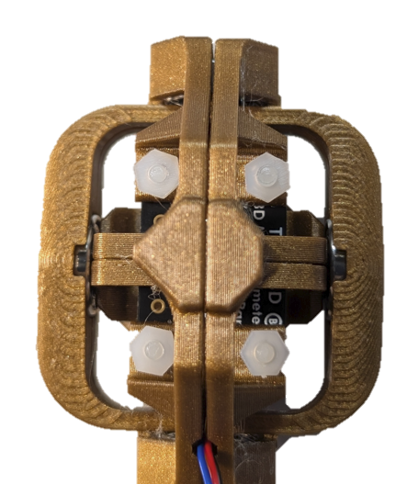

#### Step C-14: Insert the M3 Nuts

Take the two M3 nuts (C16) and insert them into the slots on the base (C17) of the joystick.

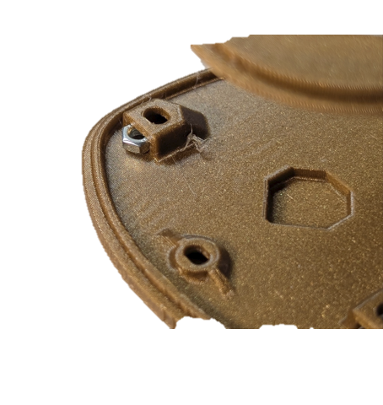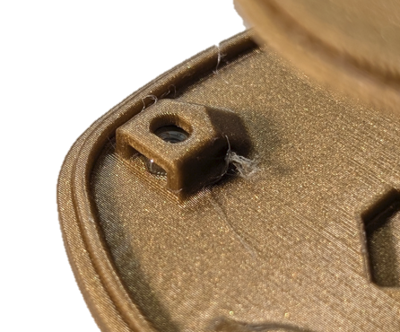

#### Step C-15: Attaching the RJ11 Jack

Slide the RJ11 jack into the slots on the inside of the base and secure it with the pin (C18). The picture below has the wires with the DuPont headers removed, but it can be assembled with or without the headers.

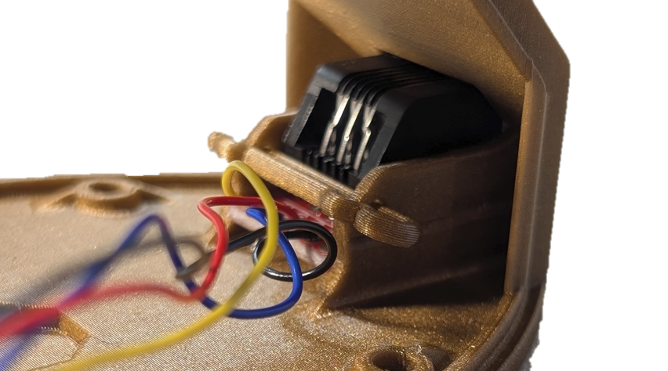

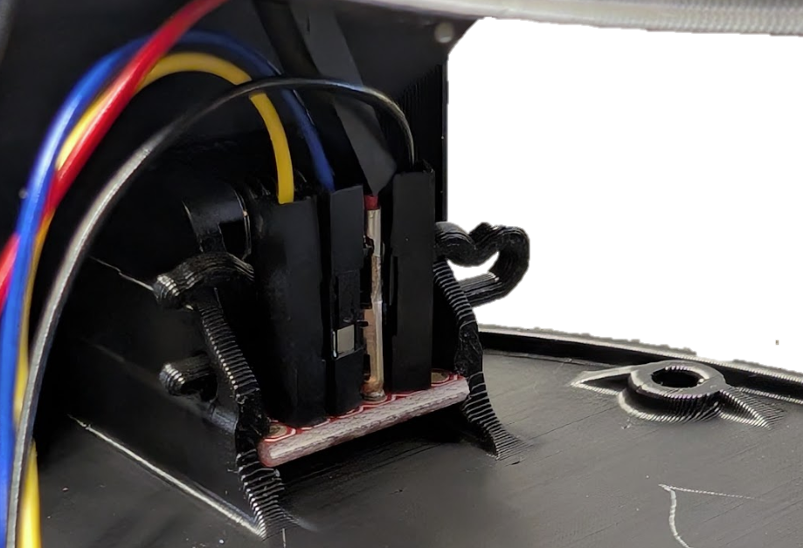

#### Step C-16: Insert the Gimbal

Wind the cable once around the base of the gimbal. Slot the gimbal into the base, with the top and bottom of the gimbal fitting in the octagons on the top and bottom of the base. The tops and bottom of the octagons of both the gimbal and the base have a slot that fit into each other so that the gimbal can only be inserted in one direction.

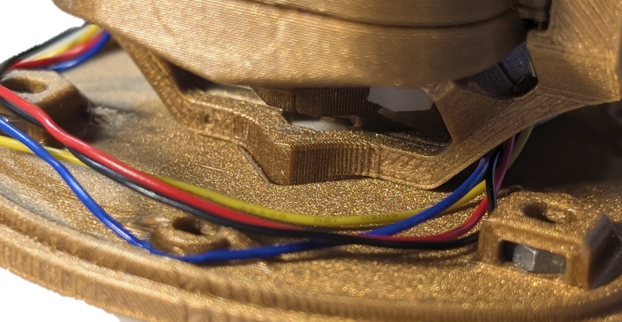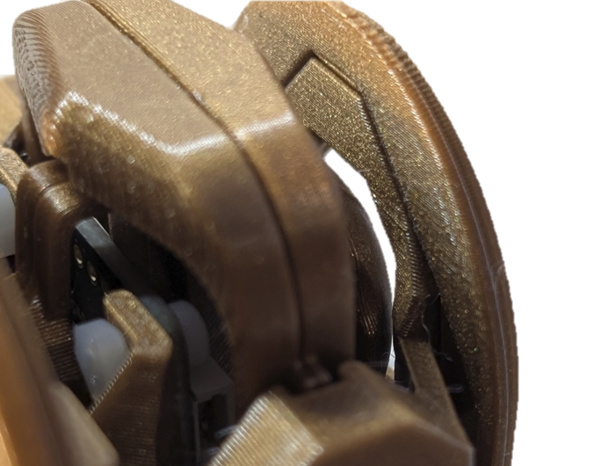

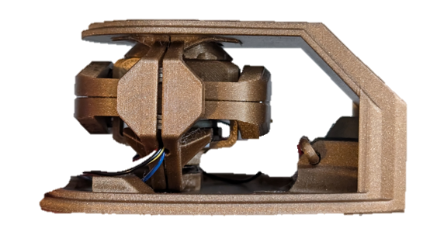

#### Step C-17: Attach the shell to the base

Attach the shell( C18) with 3 #4 sheet metal screws (C19). Be careful to not pinch the cables when attaching the shell.

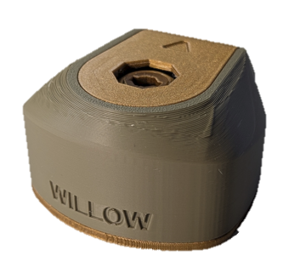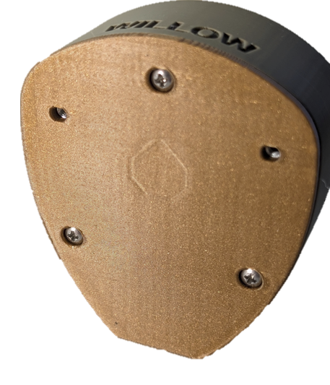

#### Step C-18: Attach the topper

Take the chosen topper (C20) from the list of toppers and insert it into the slot on the top of the joystick gimbal. Twist the joystick clockwise to tighten it, or ‘righty tighty’.

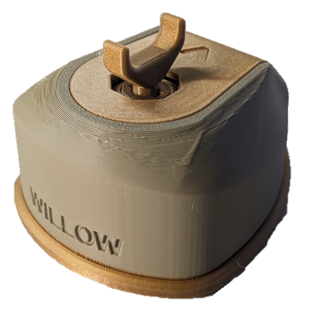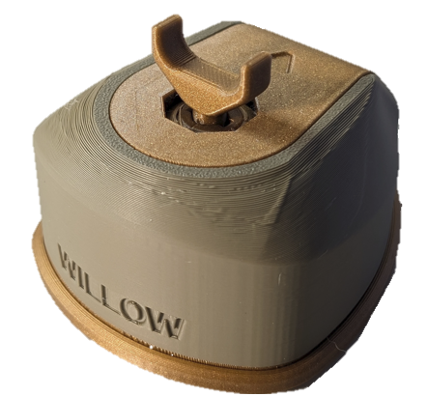

## Part D: Optional Components

### Part D: Required Components

|  |  |  |  |  |  |  |  |  |  |  |  |  |
| --- | --- | --- | --- | --- | --- | --- | --- | --- | --- | --- | --- | --- |
| Optional Components Assembly | | | | | | | | | | | | |
| D1 | | Nonslip Base | QTY: 1 | | **D2** | Nonslip Foot | QTY: 8 | | **D3** | Wrist Rest | QTY: 1 | |
| Non slip base printed in gold | | | | | non slip adhesive foot | | | | wrist rest print | | | |
| D4 | Hub Stand Front | | | QTY: 1 | **D5** | Hub Stand Leg | | QTY: 2 | **D6** | ¼-20 Bolt | | QTY: 1 |
| hub stand front frint | | | | | hub stand leg print | | | | 1/4''-20 x 1'' Hex Head Tap Bolt | LH Dottie | | | |

### Part D: Required Tools and Supplies

* Optional: Wrench or screwdriver to attach the bolt to the hub

#### Step D-01-A: Build the Non-Slip Base

Take the nonslip base print (D1) and four of the adhesive feet (D2). Remove the adhesive backing from the feet and press them onto the four indents in the bottom of the 3D print.

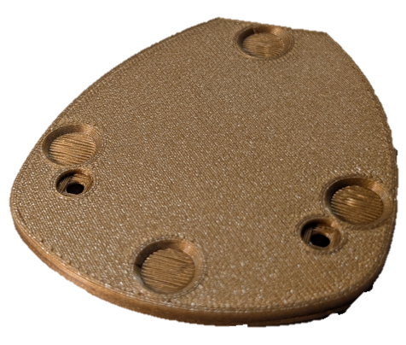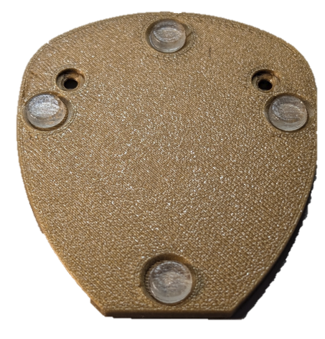

#### Step D-01-B: Attach the Non-Slip Base to the Joystick

Place the joystick on the indent on the non-slip foot and use 2 M3 bolts (D3) to attach the foot to the mounting nuts in the joystick.

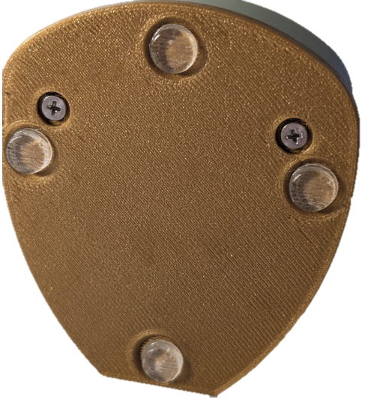

#### Step D-02: Wrist Ramp

Take the wrist ramp 3D print (D4) and four of the adhesive feet (D2). Flip over the ramp and remove the adhesive backing from the feet. Press the feet into the indents in the bottom of the wrist ramp.

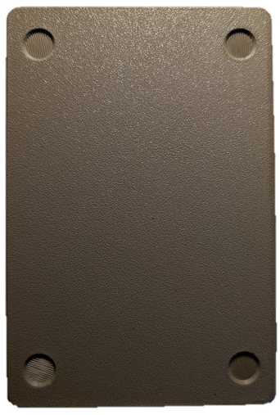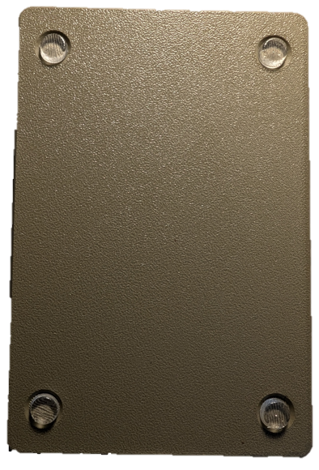

#### Step D-03-A: Clip Legs to Hub Stand

Take the hub stand front print (D5) and two of the hub stand leg prints (D6). Clip the leg prints into the slots on the back of the front print.

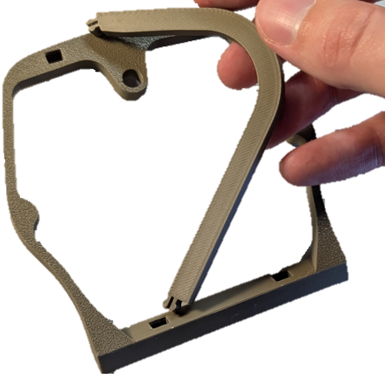 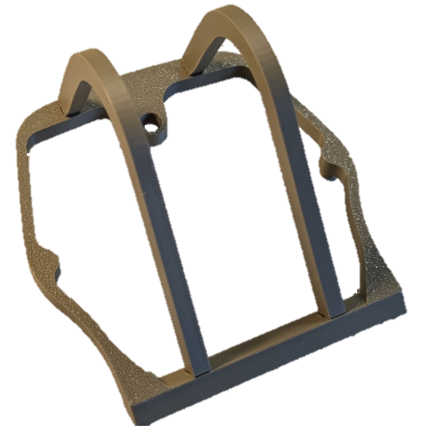

#### Step D-03-B: Attach Hub Stand to Willow Hub

Rest the Willow hub on the front stand, with the screw holes on the hub resting on the pillars on the front of the hubs stand. Use a ¼-20 bolt (D6) to secure the stand to the hub.

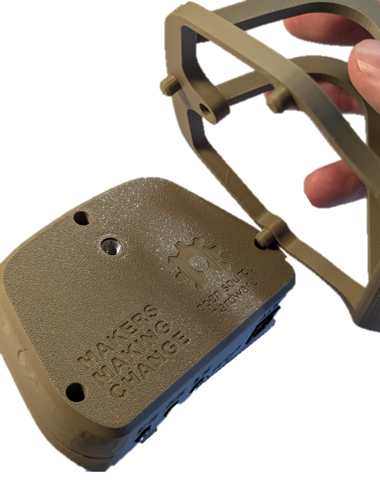 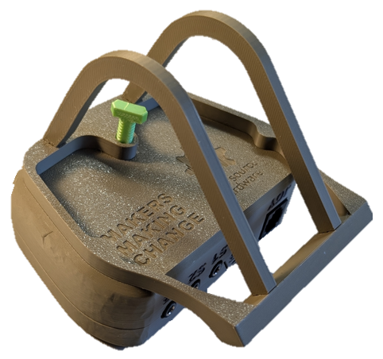

## Part E: Flashing Firmware to Willow

### Part E: Required Components

|  |  |  |  |  |  |  |  |  |  |  |  |  |
| --- | --- | --- | --- | --- | --- | --- | --- | --- | --- | --- | --- | --- |
| Flashing Firmware | | | | | | | | | | | | |
| E1 | Willow Joystick | QTY: 1 | **E2** | Willow Hub | | | QTY: 1 | **E3** | RJ11 Cable | | | QTY: 1 |
| Assembled willow joystick | | | Assembled willow hub | | | | | A picture of the RJ11 cable | | | | |
| E4 | USB-C-USB-A Cable | QTY: 1 |  | |  |  | |  | |  |  | |
| A photo of a black USB-C cable on a white background. | | |  | | | | |  | | | | |

### Part E: Required Tools and Supplies

* Computer with Arduino IDE to flash firmware

#### Step E-01: Connect the Willow Joystick to The Hub

Plug in the Joystick (F1) to the Hub (F2) using the RJ 11 Cable (F3).

#### Step E-02: Connect the Willow Hub to the Computer

Plug in the Hub (F2) to a computer via USB Cable (F4).

#### Step E-03: Setup Arduino IDE on Computer

1. Download Arduino IDE for your operating system at <https://www.arduino.cc/en/software>
2. Install the Arduino IDE.

#### Step E-04: Setup Arduino IDE for Seed Studio Xiao nRF52840 Development Board

1. Open Arduino IDE.
2. Click on **File -> Preferences**.
3. Locate the text field that says **Additional Boards Manager URLs** beside it.
4. Copy and paste the following link into the field as a new line:  
   <https://files.seeedstudio.com/arduino/package_seeeduino_boards_index.json>
5. Click on **OK.**
6. Restart the Arduino IDE.
7. Open the **Boards Manager** option from the **Tools-> Board-> Boards Manager...,**
8. **Search for “Seeed nrf52” and select “Seeed nRF52 Boards” by Seeed Studio.**
9. **Click Install to install the board.**

#### ****Step E-05: Install Libraries****

1. In the Arduino IDE, go to **Tools -> Manage Libraries…**
2. For each of the libraries in the table below, search for the name, and click Install. If prompted to install any dependent libraries, click OK.

|  |  |  |
| --- | --- | --- |
| Name | Author | Version |
| Adafruit_SSD1306 | Adafruit | 2.5.9 or later |
| ArduinoJson | Benoit Blanchon | 7.0.4 or later |
| TLV493D-A1B6 | Infineon Technologies | 1.0.3 or later |
| Adafruit_TinyUSB | Adafruit | 2.3.0 or later |

#### Step E-06: Setup Local Code Directory

1. Download the Firmware_Files from the GitHub Repository: <https://github.com/makersmakingchange/Willow-Joystick/blob/main/Build_Files/Firmware_Files/Willow_Firmware.zip>
2. Extract / unzip the folder to a known location.
3. Confirm that you have the following folder structure:

* Willow_Firmware (folder)
  + Willow_Firmware.ino
  + LSAPI.ino
  + LSTest.ino
  + LSBLE.h
  + LSBuzzer.h
  + LSCircularBuffer.h
  + LSConfig.h
  + LSInput.h
  + LSJoystick.h
  + LSMemory.h
  + LSOutput.h
  + LSScreen.h
  + LSTimer.h
  + LSUSB.h
  + LSUtils.h

#### Step E-07: Upload the Code to the microcontroller.

1. Open Willow_Firmware.ino with Arduino IDE.
2. **Select Seeed Xiao NRF52840 from Tools -> Board -> Seeed NRF52 Boards**
3. Connect the Willow using the USB cable to the computer.
4. Select the correct port from **Tools -> Port** menu.
5. Verify and upload the code.

# Troubleshooting

1. **My Arduino IDE is stuck when uploading code to the board.**

You can first try to reset the board by clicking the "Reset Button" once. If that does not work, rapidly click it twice to enter bootloader mode. If that also doesn't work, disconnect the board from the PC, and connect the board again.

1. **My board is not showing up as a serial device on Arduino IDE.**

You can first try to reset the board by clicking the "Reset Button" once. If that does not work, rapidly click it twice to enter bootloader mode.

# Testing

After building the Willow Hub and Joystick, you must verify both units are functioning properly.

## Testing the Willow

1. Does Display turn on?
   1. Ensure that the Willow joystick in plugged into the Hub using the RJ11 cable.
      1. Ensure that the Willow Joystick light pipe lights up green.
   2. If the Hub turns off and does not work, reset the device, and open the serial monitor in Arduino IDE right after resetting to see if one of the STEMMA boards is not being recognised.

### Testing Mouse Mode

Refer to the Willow User Guide for instructions on how to connect the Willow to a Host Device and change the operating mode to USB Mouse Mode. When in USB Mouse Mode, ensure moving the joystick moves the mouse cursor. Additionally, test the external switches and buttons on the Hub. Ensure that each external switch and Hub button action are consistent with the following tables.

### Testing External Switches

Plug an assistive switch into the external switch jacks and activate the assistive switch. S1 is the left switch, S2 is the center switch, and S3 is the right switch.

The behaviour for each switch and type of activation is outlined in the table below:

|  |  |  |  |
| --- | --- | --- | --- |
| Input | Mouse | Gamepad | Menu/Settings Mode |
| S1 Short Press | Left Click | Button 1 press | Next |
| S1 Long Press | Start drag mode | Button 3 press | N/A |
| S1 Very Long Press | Enter settings mode | Enter settings Mode | Exit settings mode |
| S2 Short Press | Middle Click | Button 5 press | N/A |
| S2 Long Press | Middle click | Button 6 press | N/A |
| S2 Very Long Press | Perform Center Reset | Perform Center Reset | N/A |
| S3 Short Press | Right Click | Button 2 press | Select menu item |
| S3 Long Press | Start scroll mode | Button 4 press | N/A |
| S3 Very Long Press | Middle click | N/A | N/A |

### Testing Hub Buttons

Ensure the following behaviours are consistent when pressing the buttons on the Hub.

|  |  |  |  |  |  |  |  |
| --- | --- | --- | --- | --- | --- | --- | --- |
| **Willow Hub Button Inputs** | Select Short Press | Select Long Press | Select Very Long Press | Next Short Press | Next Long Press | Next Very Long Press | Next and Select |
| **Mouse Behaviour** | Left Click | Start Drag Mode | Enter Hub Menu | Right Click | Start Scroll Mode | Middle Click | Next and Select |

#### Input Feedback

Each LED is designated to a set of inputs:

**Left LED** ·: Next (Hub), S1

**Middle LED** ··: S2

**Right LED** ···: Sel (Hub), S3

The time durations Short, Long, and Very Long for the switch/button inputs are the following:

**Short**: Less than 1 seconds. Indicated by the respective LED blinking once button is released.

**Long**: Between 1 to 3 seconds. Indicated by the respective LED turning on and staying on.

**Very Long**: 3 seconds or longer. Indicated by the respective LED turning off.

Ensure the LEDs behave as outlined above.